Initial Model Findings and Process

Collecting Data

Data collecting process
First our team started with collecting data from the Mentor’s original provided resource SHELDUS. From there the team collected data specifically for floods in the Midwest region of the United States from the years 1960 to 2024. The hazard specified was flooding with the losses being property and crop losses- which was also aggregated by year, hazard, and county.
After cleaning the initial data from SHELDUS, the team found that the SHELDUS data alone was not enough for predicting impact and needed other data to assist in hazard and exposure. So the team collected data from NOAA and NHGIS. The NOAA data was specifically for precipitation by division and state, and the NHGIS was for median home value data.

Files Produced
- loss_cleaned.csv: SHELDUS data with log columns and artifact flags (data_clean.py)
- model_data_DU.csv: SHELDUS-only history features (“DU” = don’t use; superseded)
- model_data_hazard.csv: History + rainfall features (hazard_features.py)
- model_data_exposure.csv: History + exposure features (exposure_features.py)
- model_data_combined.csv: History + rainfall + exposure, 17,962 rows, 31 columns

Determining Features/Variables

Cleaning the data
When cleaning the data, SHELDUS data did not need any removals however it was found that many of the entries had rounded values specifically for the dollar amount of losses and that there seemed to be a shift in how records were kept within the SHELDUS data. These were then turned into flags that were added as extra columns. Additionally, conversion of the dollar amounts was handled to ensure that it reflected 2024 pricing by doing log(x+1).

Spearman Rank
When comparing whether the variables within the SHELDUS data were correlated Spearman Rank was used so that large dollar amounts would not skew the correlation data between the variables. It was found that damage, duration, and records alone cannot be used to predict the impact since they are only known after the flood has happened- which facilitated the need to search for more data that was available before the flood. It was also found that crop and property damage often happened together but not always.

Overtime
In the data it was also found within the SHELDUS data that there were a few floods that dominated the numbers such as the Great Midwest Flood and Red River, but the flood losses don’t seem to be increasing over time.

Finding Variables
Hazard_features.py and exposure_feature.py both take in outside data from the NOAA and NHGIS datasets and builds candidate variables through using Spearman Rank and a model test to get MAE (to see if a variable improved predictions, median regression). For the NOAA data, it involved rainfall for specific divisions/states across the US and their precipitation in inches. From the data 9 features were created and were scored with Spearman against the Property damage. Then the NGHIS data, which involved urban housing and crop loss, created 6 features that were scored the same way.
Overall, the MAE of both scripts allowed us to narrow down the variables to max precipitation, urban share, log of the crop value, and the State. Urban share and crop value together also show why there is a difference in county to county home value, so home value itself is not actually needed.

Finding Variables
- Maximum Precipitation Anomaly
- Urban Share
- Log of Crop Value
- State

Creating the Initial Impact Model and Results

Training
For the actual impact model we started with linear regression as a simple first version. We then check its accuracy through MAE, RMSE, and R^2 and its correlation with Spearman again. The split was done by time from 2000-2016 and tested with 2017-2023 and the feature groups were exposure only (x); exposure + context (x, c); pre-event only (w0, x, c, where w0 is the previous fall’s rainfall).
The training was done by fitting an ordinary linear regression to 5,125 county-years from 2000–2016 through NumPy's lstsq. Before fitting, missing values were filled with the training median and each variable was put on the same scale using only the training years, so no information from later years leaked in. The learned weights were then applied to 1,597 county-years from 2017–2023 that the model had never seen, and its predictions were compared with the actual damage using MAE, RMSE, R², rank correlation and the top 10% hit rate.

Results
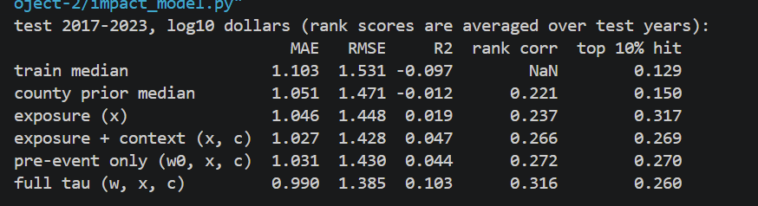
These mean that the model performs better than a simple baseline, but only modestly. Compared with always predicting the typical damage value, the full model reduces average error by about 10% and explains about 10% of the variation in losses, and a typical prediction still differs from the actual loss by roughly a factor of ten. A smaller model with only the strongest variables improved on the baseline by about 6% (the four strongest features mentioned previously). Rainfall was the most important input and gave the largest improvement in every test. This is consistent with the finding that most of the variation in damage occurs from year to year within the same county, which rainfall captures. Exposure variables, such as population and housing, contributed little to estimating damage amounts, but they were useful for identifying which counties are likely to have the highest losses.

